

*Notebook’s R Us – Something for Everyone!*

Corporate Powerhouse (available in 15” and 17”)

**HP 4540s**

15.6” Screen, I7 3632QM Processor, 8GB RAM, 750GB 7200rpm HDD, 7650 2GB Radeon Graphics, 1 year warranty included, Windows 7 (+ 8 License), Bluetooth, wireless, USB 3.0, reinforced corporate chassis, spill proof keyboard.

**Perfect for: Power office use, including high end corporate and media software compatibility, future proofing for 4 years. $1299**

Corporate Traveler

**Toshiba Z930 i7**

13.3” Screen, i7 3687u Processor, 8GB RAM, 256SSD, 3 year full warranty (includes pickup and return), 1.12kg, wifi, Bluetooth, 8 cell battery, USB 3, reinforced corporate chassis.

**Perfect for those who require the performance of a high-end machine in the body of a low profile unit. SSD for additional speed and reliability. Will fit in hand luggage easily.**

**$1849**

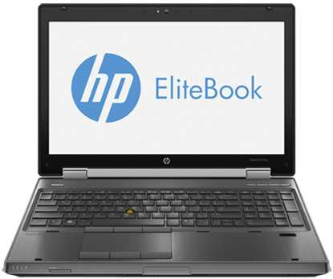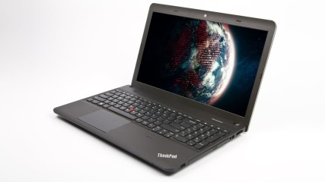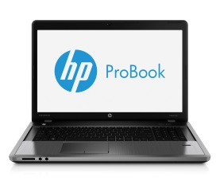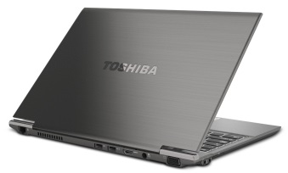

Our repairs division has over 30 years’ experience in repairing electronic repairs. No problem is too big or too small. Call now for a free over the phone appraisal! Data recovery, niggling problems, hardware faults, virus removal, software issues

Power User

**HP 8570w**

15.6” screen, i7 3720QM Processor, 8GB of RAM, 256SSD + 500GB HDD, K2000 Nvidia Quadro, Windows 7, 1920 x 1080p Full HD screen, full 3 year onsite warranty, 8 Cell battery, card read, Bluetooth, all the trimmings expected on a high end unit.

**Perfect for: High end graphical manipulation, those that require large storage space, workstation level of power, very detailed screen, additional reliability (3 year warranty), and unmatched processing speed. $2349**

Everyday User (available in 14” and 15”)

**Lenovo E531**

15.6” Screen, i5 3230m Processor, 4GB RAM, 500GB HDD, Windows 8 Pro, 1 year warranty, wireless, Bluetooth, flat low profile design

**Perfect for: General office or home use – word, excel, outlook, internet surfing, multiple application use, future proofing for 4 years with a powerful i5 processor.**

**$849**

|  |
| --- |
| *253 Victoria Street*  *Abbotsford VIC 3067*  *Phone: 03 9417 1300*  *Website:* *www.notebooksrus.com.au*  *Email:* [*ed@notebooksrus.com.au*](mailto:ed@notebooksrus.com.au?subject=Deals%20For%20Everyone) |
|  |